*** MAKE SURE SSMS IS DOWN BEFORE U START *****
- Create directory for deployment eg: d:\ssis
- Copy the following files to d:\ssis
- NBS_ETL.ispac
- NBS_Server_Config1.dtsConfig
- Set System Variable
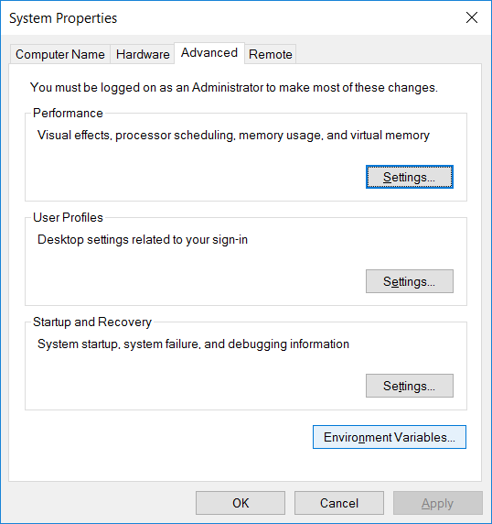

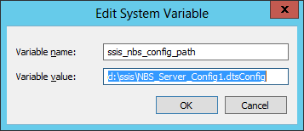
Check that the variable is set correctly by opening command prompt and running command > SET
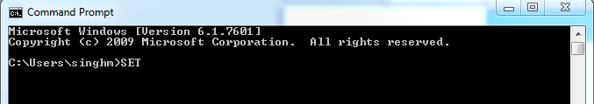
- Edit NBS_Server_Config1.dtsConfig, Replace in NBS_Server_Config1.dtsConfig file items highlighted in BOLD: (“TEST1” exists in 2 places)
<ConfiguredValue>Data Source=TEST1;User ID=sa;Initial Catalog=RDB; password=Nedss123!;Provider=SQLNCLI11.1;Persist Security Info=True;Auto Translate=False;</ConfiguredValue>
Change Sa password
- Steps for making sure Windows user is also admin user in SQL Server.
- Create SSIS Catalog by opening SSMS->under SQL Server instance->Integration Services Catalog -> Right Click ->Create Catalog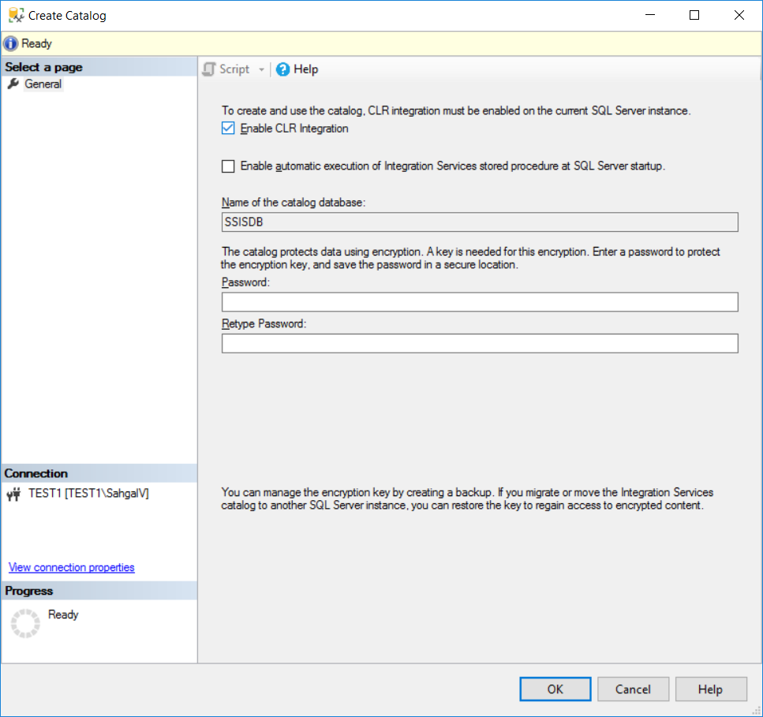
Fill in password of your choice.
- Create SSIS Folder
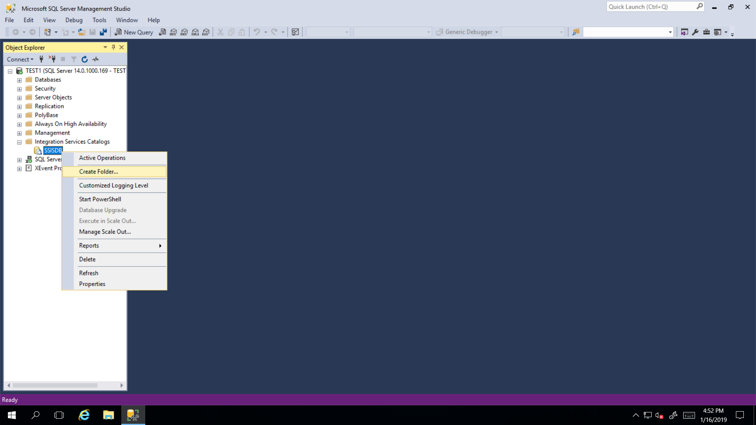
Folder name: NBS_ETL
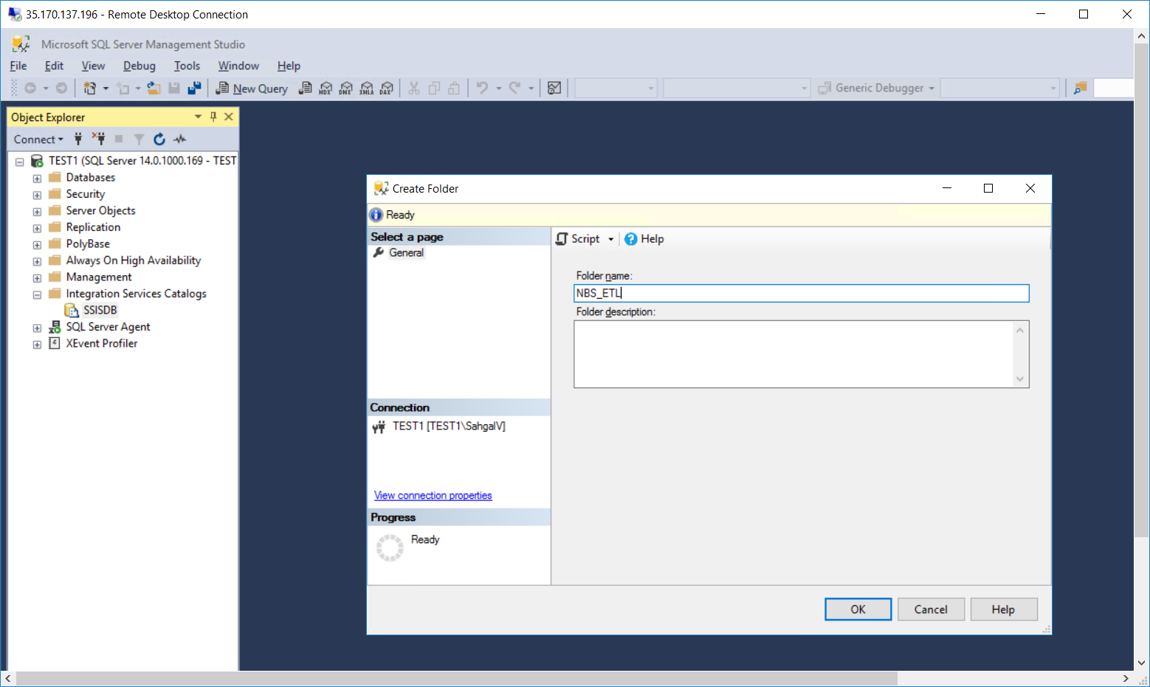

- Deploy SSIS Package
Click SSISDB -> NBS_ETL -> Right click on Projects
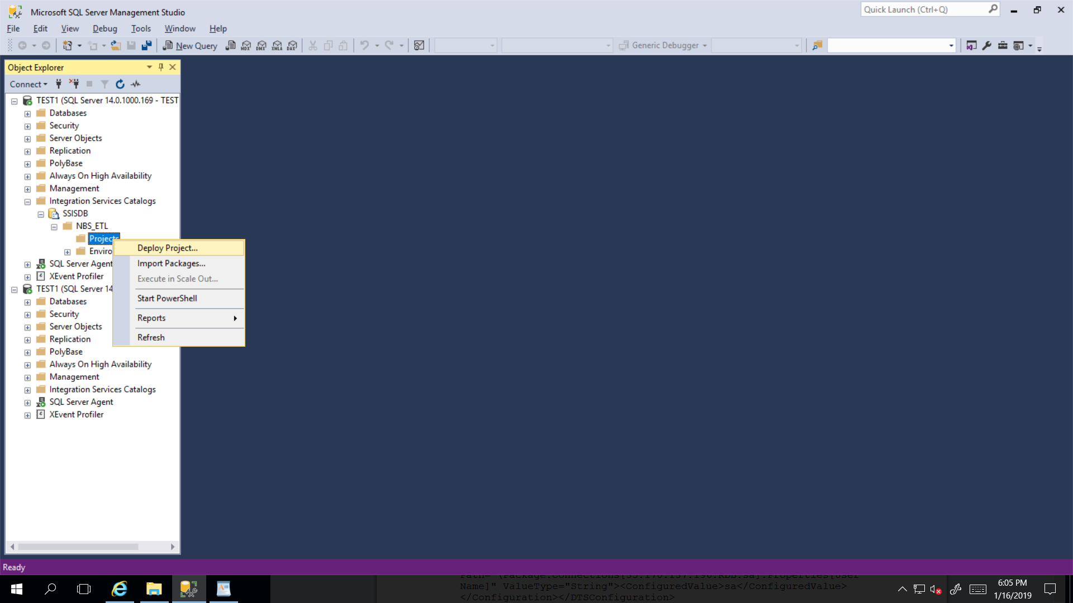
NOTE: - Use the path created in step 1
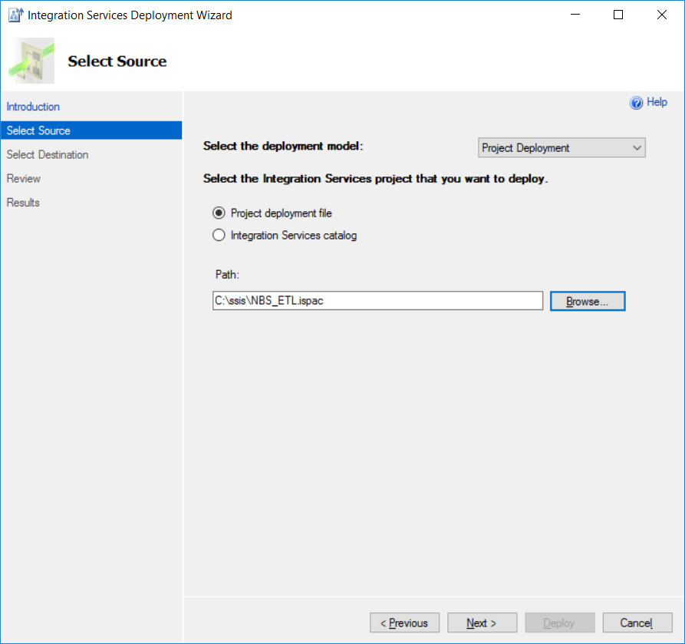
Use path to file “NBS_ETL.ispac” from step 2
- Click Next
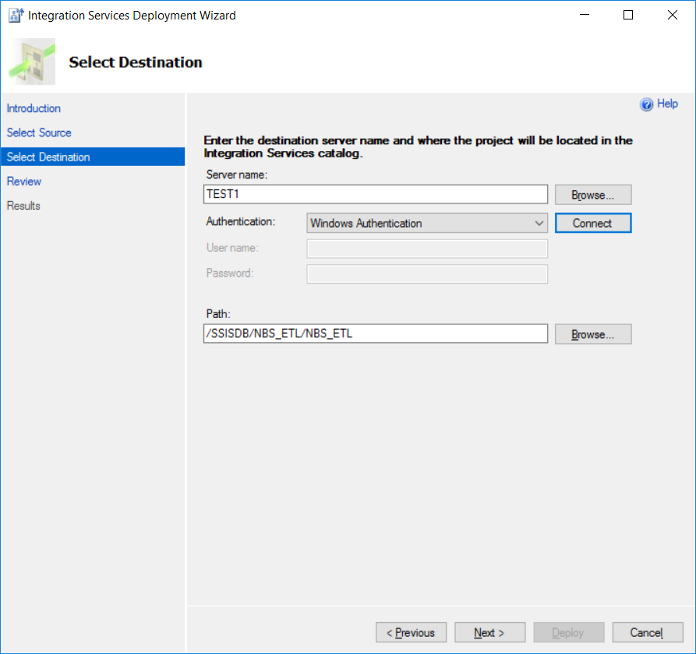
- Click Connect
- Click Next
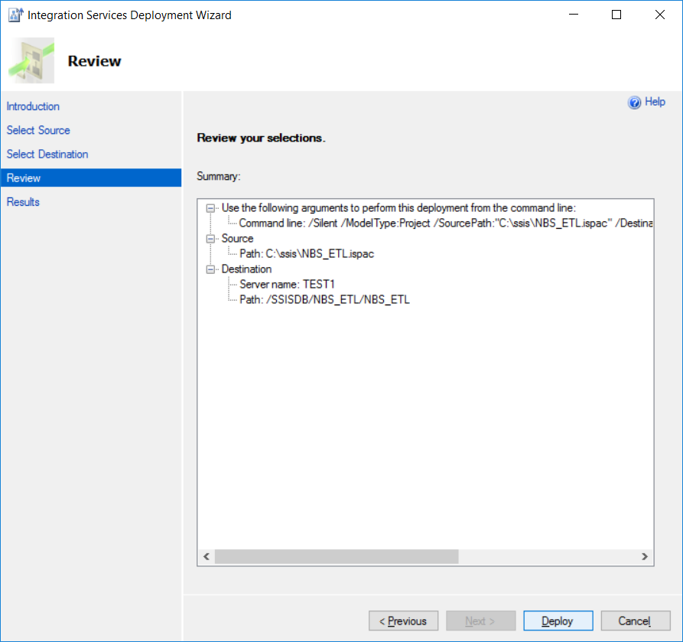

- Click Deploy
- Click Close
- Execute and Test SSIS dtsx
Expend the folders and right click NBS_PageCase_SSIS.dtsx

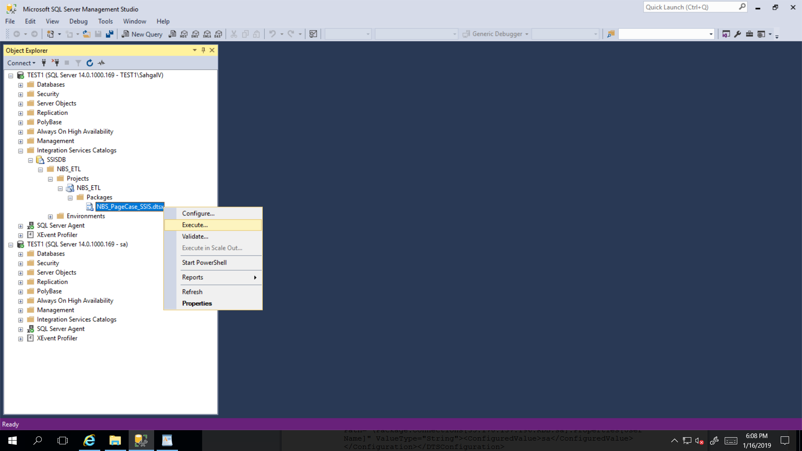

- Click OK
- Click Yes

